PoC Proposal Template

1 PoC Project Details

1.1 PoC Project
PoC Number (assigned by ETSI):
PoC Project Name:
PoC Project Host:
Short Description:

1.2 PoC Team Members
 | Organisation name | Category  (Manufacturer/ Network Operator/Other) | TB participant  (yes/no) | Role / Components | Contact (Email) | PoC Coordinator  (*)
1
2
3
…

All the PoC Team members listed above declare that the information in this proposal is conformant to their plans at this date and commit to inform ETSI timely in case of changes in the PoC Team, scope or timeline.
(*) Identify the PoC Project Coordinator (main point of contact) with an X.
NOTE: It is recommended that the PoC Project Coordinator is also a member of the NTECH AFI Working Group.
Note: PoC Team composition criteria can be found in the NTECH AFI PoC Framework

1.3 PoC Project Scope

1.3.1 PoC Topics
PoC Topics identified in this section need to be taken from the PoC Topic List identified by NTECH AFI WG and publicly available in the NTECH WIKI (ntechwiki.etsi.org) POC Topics. PoC Teams addressing these topics commit to submit the expected contributions in a timely manner. Once specified here, these expected contributions become “Committed Contributions” for this PoC.
PoC Topic Id | PoC Topic description | Committed Contribution (PoC Feedback) | Target Date | Additional Information

1.3.2 Other topics in scope
List here any additional topic for which the PoC plans to provide input/feedback to the TC NTECH AFI
PoC Topic Id | PoC Topic description | Ref WI(s) | Target WI(s) | Expected Contribution (PoC Feedback) | Target Date

1.4 PoC Project Milestones
PoC Milestone | Milestone description | Target Date | Additional Info
P.S | PoC Project Start
<P.TP> | <PoC Test Plan> |  | Use PoC Test Plan template
P.D1 | PoC Demo 1 |  | Venue, F2F / Webinar
<…> | …
P.C1 | PoC Committed Contribution 1
<P.C2> | <PoC Committed Contribution 2>
<…> | …
P.R | PoC Report
P.E | PoC Project End

Note: Milestones need to be entered in chronological order

1.5 Additional Details
URL, planned publications, conferences, etc…

2 PoC Technical Details

2.1 PoC Overview
Describe the PoC here.

2.2 PoC Architecture
Describe the PoC Architecture here. Include a schema (based on figure 1) outlining:
- How the different PoC components map to the GANA reference architecture (ETSI GS AFI 002), summarized in Clause 2.3, figure 1.
- How the PoC use case can map to ETSI/NTECH Use Cases described in ETSI TS 103.194. If no direct mapping, indicate how this new Use Case relates to existing ones.
- The GANA Hierarchical Levels implemented by the PoC and associated GANA DEs in scope.
- The implemented Managed Entities (MEs) attached to each DE
- The implemented reference points (Rfps) associated to the DE-DE relationship and DE-MEs relationship (Vertical Rfps and Horizontal Rfps)
Summarize the information in the table below:
PoC Topic Id | Use Case | GANA Level | GANA DEs | Associated MEs | Reference points (Rfps) | Comments

2.3 Additional Information
AFI PoCs intend to demonstrate autonomics at a single level and/or multiple-levels of the GANA reference model’s decision-making hierarchy and associated control-loop(s), as depicted in Figure 1 (ETSI GS AFI 002), at which the autonomic function (Decision making Element (DE)) is designed to operate. The structure of a control-loop’s components articulation i.e. the articulation of a DE and its associated Managed Entities (ME(s)) and their configurable & controlled parameters, and the inputs and outputs on the interfaces of the DE, should be illustrated as core part of the PoC demo (including what is communicated at Vertical Reference Points (VRPs) and Horizontal Reference Points (HRPs) and the methods (e.g. protocols) used for the communications). Regarding DE-ME mapping relationship, the means of interactions between the two also needs to be illustrated.

Note 1: Apart from “views” exposed to a DE by its associated MEs, a DE can have (in addition) other types of information suppliers to its decision-making logic. A PoC may demonstrate a particular level of autonomicity in GANA or multiple levels and the way the levels complement each other in decision-making:

Note 2: For each GANA Level not covered by the PoC, provide ideas (if any) on how autonomic behavior at this level could complement autonomic behavior at the level(s) covered by your PoC

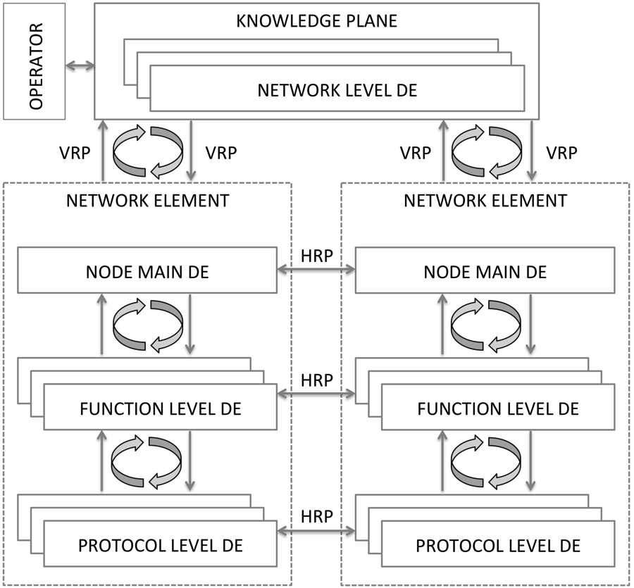
Figure 1: GANA reference model
The Table below serves to summarize the nature of autonomicity at the various GANA levels captured by the GANA Reference Model diagram (Figure 1)..

ETSI / NTECH AFI GANA reference model hierarchical level | Comments
Protocol level | Relates to any managed entity (ME) such as protocol, network service enabler, software components, and other fundamental mechanisms.  They may exhibit intrinsic control-loops and associated Decision-making Logic (i.e. a DE) (as it is the case for most of today’s protocols such as OSPF)  (Refer to ETSI GS AFI 002 for more details)
Function level | Relates to a DE for collective autonomic management and control of a group of protocols and mechanisms that are abstracted (viewed like a bundle) by a “networking or a management/control function” such as “routing management-DE”; “forwarding management-DE”; “Quality of Service management-DE”; “mobility management-DE; “monitoring management-DE”; “service and application management-DE”. Currently these six Function Level DEs are defined in the GANA Reference Model .The control-loop is external to the individual protocols and mechanisms subscribed to the “Function” (by virtue of abstraction). Multiple DEs at this level are determined by the “functions” required of the node/device.  (Refer to ETSI GS AFI 002 for more details on the types of DEs for this level and their associated types of managed entities)
Node level | Relates to a DE for autonomic management & control of those aspects that cover and restrict the behavior of the node as a whole, as well as the orchestration and policing of the “Function Level”.  GANA Level 3 specified the following four DEs : “Security Management DE”, “Fault Management DE”, “Auto configuration and Discovery DE”, “ Resilience and Survivability DE”. Those four DEs are seen as “Node-Main-DEs”.  (Refer to ETSI GS AFI 002 table 1for more details on the types of DEs for this level and their associated types of managed entities)
Network level | Relates to a DE for autonomic management & control of those aspects that cover network-wide views and the management & control of lower levels e.g. node/device levels, as well as the policing of the lower levels ( e.g. “Node Levels”). The Control-Loops at this level complement lower level control loops by operating on slower timescale (i.e. they are slower control-loops in contrast to lower level control-loops (the faster control-loops)).  The Network Level DEs constitute the Functional Blocks of the Knowledge Plane, together with ONIX (Overlay Network for Information eXchange) and MBTS (Model-Based-Translation Service).  The Network-level DEs reflect the higher-level DEs in the GANA hierarchical reference architecture the lowest level is “Protocol level”  (Refer to ETSI GS AFI 002 for more details on the types of DEs for this level and their associated types of managed entities).

